Home learning Pearl & Emerald (04/05/20)
**Our new topic for Summer Term is the Solar System. **
Literacy  Write 5 sentences about what you already know about the Solar System. Use the sentence starter- I know..  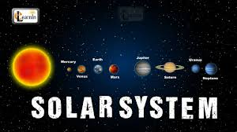  Here is a Pobble 365 picture of The Magic Tree. Write sentences for this picture with the sentence starters  I see….  I think…  I wonder...  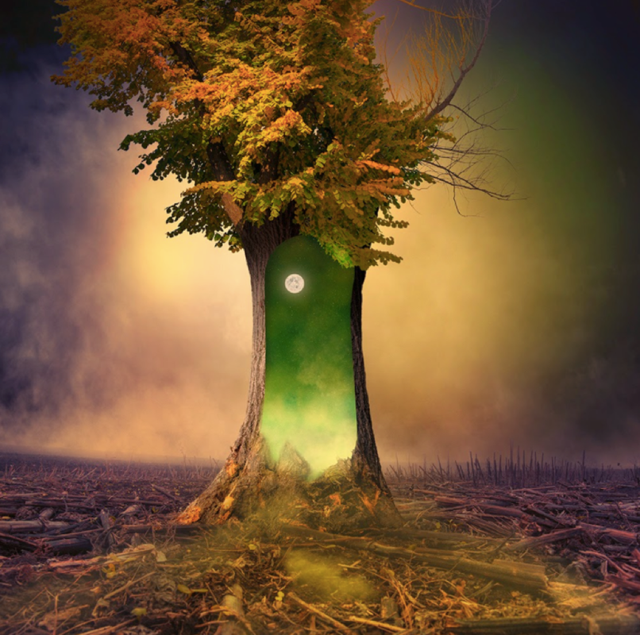 | Numeracy  Draw 2D shapes and write the properties e.g. A triangle has 3 sides and 3 corners.  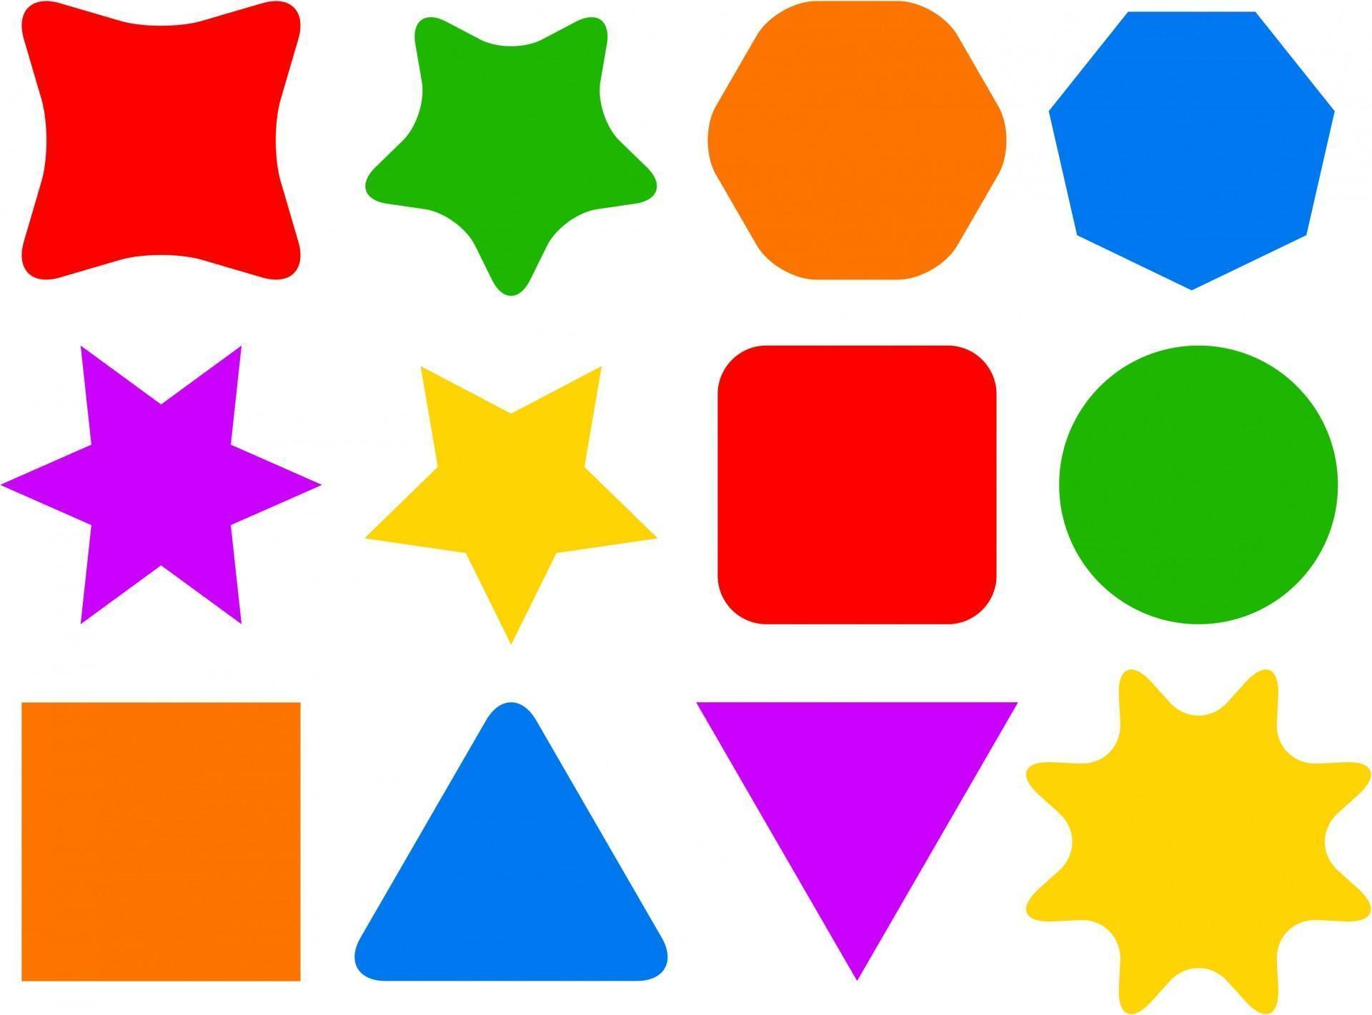  Practice your CLIC, Learn Its and Safe questions. | Digital Competence  Create a front cover for our new topic ‘Solar System’. You can do this on your computer using Google Docs or on paper.  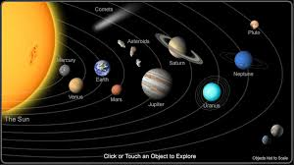  SOLAR SYSTEM!  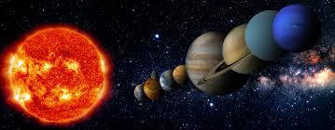
Modern Foreign Languages  Find out the names of the different planets in a range of languages e.g. Welsh, Arabic, Spanish, Czech and your own language. | Welsh  Can you write sentences about what subjects/sports you like or don’t like.  Write 5 sentences using ‘Dw i’n hoffi’ and 5 sentences using ‘Dw i ddim yn hoffi’.  Try and join them with ‘ond’.  For example:  Dw i’n hoffi Saesneg ond dw i ddim yn hoffi Celf. | Science & Tech  Can you research the different planets, including the name of each planet, it’s size and a cool fact about each planet. 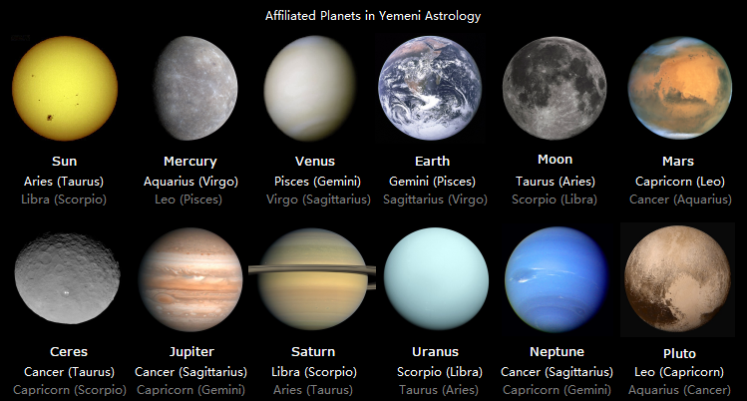
Health & Wellbeing  Our Right of the Month is Article 31- Children have a right to relax and play.  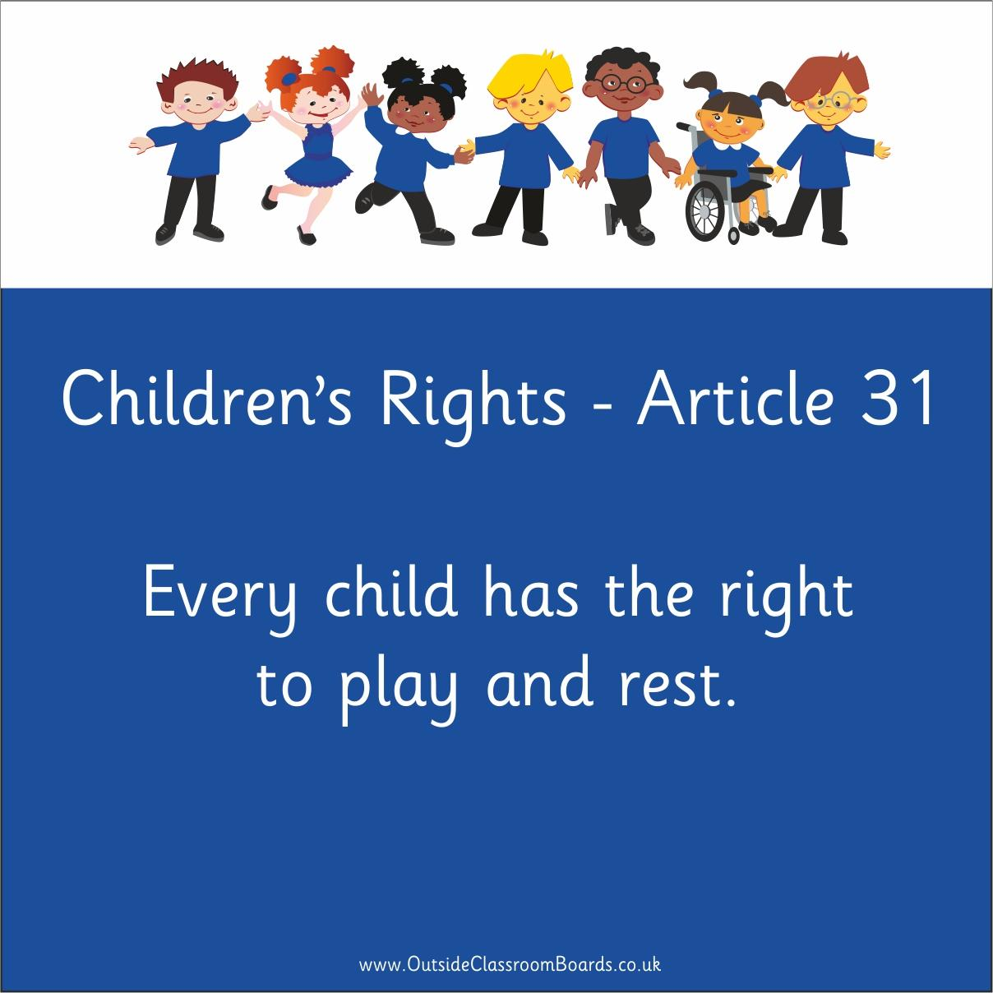  Have a go at ‘Cosmic Kids Yoga’ https://www.youtube.com/watch?v=CYQJdn8gapw  Maybe get a family member to join in with you.  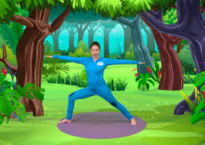 | Expressive Arts  Design and make your own rocket ship to explore the solar system.  It could be a piece of 2D or 3D art using any medium you would like.  Take a photo and share it on Twitter.  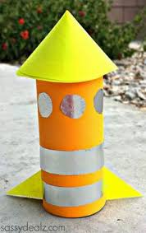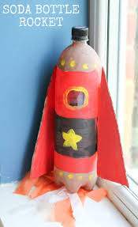 | Humanities  Create a fact file about the First Moon Landing in 1969.  Use:  https://www.bbc.co.uk/newsround/48789792 as a good starting point for you.  