Home Learning Grid
Fortnight Beginning: 18.05.20
Alongside the learning tasks on Google Classroom, you could complete any of these activities. If you choose to complete them digitally share them with your teacher.
Please complete the survey (link below) to have your say on how the lockdown has affected you. It’s really important that the people in charge of Wales know how you feel! #pupilvoice.
https://www.childcomwales.org.uk/coronavirusandme/

Literacy    The lock down has changed the way we live our day-to-day lives. Create a comparison table, timetabling your typical day before lockdown and your typical day during lockdown. What are the similarities/ differences? Which day do you prefer? Why?  Time of Day Before Lockdown During Lockdown  7am- 8am Wake up Get dressed have breakfast Still asleep  8am- 9am Walk to school Say hi to my friends Wake up Have breakfast do PE with Joe Wicks | Numeracy  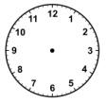  Find out the distance of the planet from the sun, in KM or miles.  Can you read each number?  Try to write them out in words and then put them in order from smallest to largest. | Digital Competence    Log in to Hwb and then watch a video (webinar) about Adobe Spark Video using the link below.  https://web.microsoftstream.com/video/1932b7a8-be09-4673-8c93-572f39ecd9a3  Once you have watched the webinar, open up Adobe Spark from the Hwb homepage.  Explore Adobe Spark Video and have a go at creating your own project using the features you saw being used in the webinar.  Have fun!
Modern Foreign Languages  Which countries have the most languages? What are they? Have the languages changed over the years?  Present your findings in your own way.  (You could record the data you collect in a bar chart, using Google Sheets.) | Welsh  In school lots of objects are labelled in English AND Welsh. Let’s make your home a bit more like school!  Label items in your home in English and Welsh. Remember DO NOT use glue or Sellotape on your labels – simply putting a little piece of scrap paper next to the item will do!  Success Criteria:  ● Use one colour for English words and a different colour for the Welsh words  ● Check the spelling before you label the item  ● Recall your Welsh alphabet when spelling the trickier Welsh words. | Science & Tech  View the moon every day/night for 28 days. Record the shape of the moon each day and observe how the shape changes.  Use the link below to find out more about the phases of the moon.  https://www.natgeokids.com/uk/discover/science/space/the-phases-of-the-moon/  Did you see each phase of the moon during your observation?
Health & Wellbeing  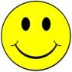  Think about the people/actions/things that are MOST important to you. Why are they so important?  Think about the things that you used to think were important before lockdown but are not so important now. Why are they less important?  Write it down! | Expressive Arts  Create your own solar system art work.  You could choose to:  - paint  - sketch  - colour in  - collage  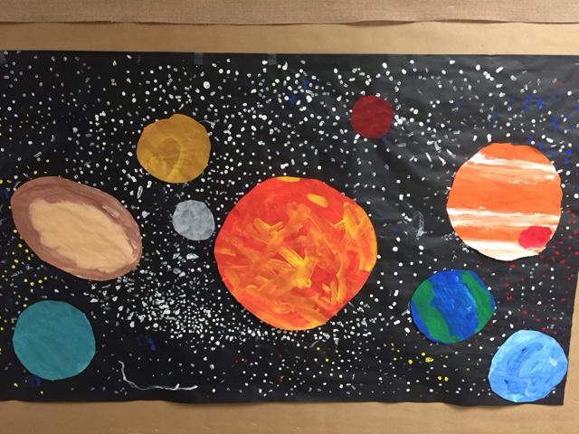 | Humanities  Find out about the traditions and values of another culture.  You could research traditional food, clothes, music, dance,  

