Dosbarth Comet Maths Learning Grid
Week Beginning 30.03.20

Can you write all of the number bonds to 10?  1+ __ = 6+ __ =  2+ __ = 7+ __ =  3+ __ = 8+ __ =  4+ __ = 9+ __ =  5+ __ = 10+ __ =  You could do this outside using chalk or water. | Play ‘hit the button’ to help you with your number bonds!  https://www.topmarks.co.uk/maths-games/hit-the-button  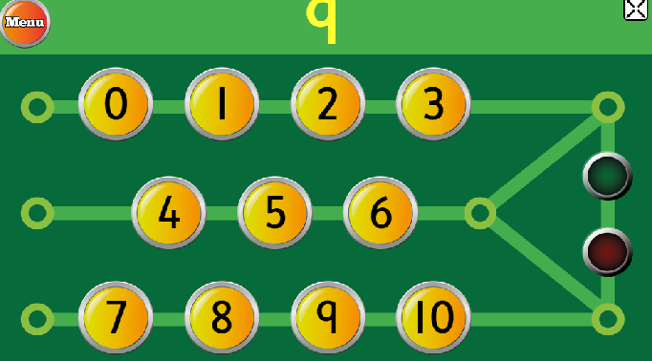 | Go on a counting hunt - how many of these have you got at home?  Object How many?  spoons  doors  stairs  windows  rooms
Can you practice writing your numbers correctly?  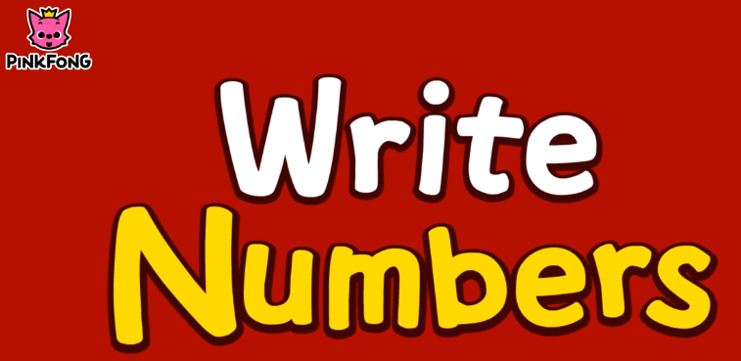  This is the video we use in school https://www.youtube.com/watch?v=DzKqCmjVXLI | Play the ‘10 frame’ game - how many more do you need?  https://www.nctm.org/Classroom-Resources/Illuminations/Interactives/Ten-Frame/  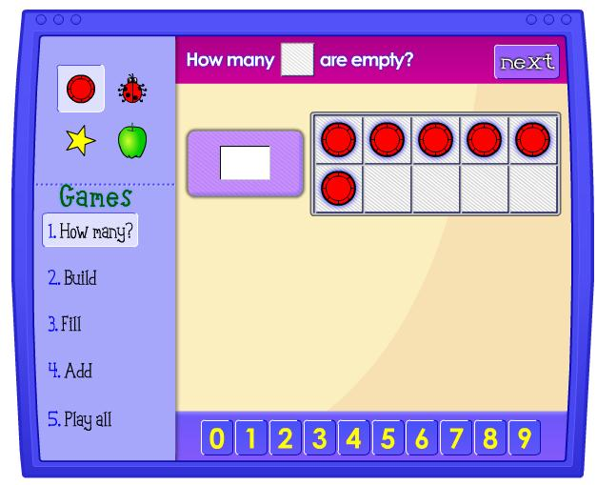 | How high can you count?  Count out different amounts using things around the house  