Dosbarth Comet English Learning Grid
Week Beginning 30.03.20

Talk and ask questions about the story using our question words What? Where? When? Who? How? | Listen to my story on youtube: https://www.youtube.com/watch?v=ICxLOO9pua0 | Can you draw a monkey and label the different parts of the body?  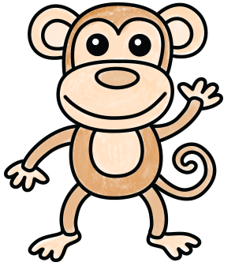  ear  hand  tail  foot
Can you make a list of the animals the monkeys meet at day / night time?  Night Day  Bats Frogs fireflies Butterfly Parrots chimps | This week I am reading:  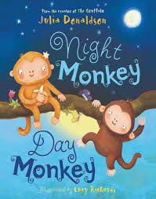 | Can you draw a night or day time picture and write about it?  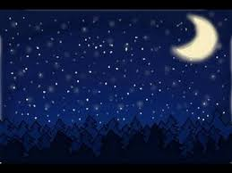  It is dark at night time. The stars shine brightly. The moon is big and yellow. It looks like a banana.
Practice writing your HFW from the story:  I  a  and  the  on  of  said | Can you act like some of the animals in the story with Shonette? https://www.youtube.com/watch?v=qzRQmo4Aojg | Monkey starts with ‘m’ write or draw a list of other things that start with ‘m’.  mop  mat  mouse

If you want to choose another story you can use your favourite from home.

