|  |  |  |  |  |  |
| --- | --- | --- | --- | --- | --- |
|  | Monday | Tuesday | Wednesday | Thursday | Friday |
| English | Let's start the week right by listening to the amazing book, ‘My Granny is a Pirate’ by Val McDermid. <https://www.youtube.com/watch?v=t8ZKIvRblpM> | Yesterday's story is about a very cool Granny! Tell me something you like about each family member that you live with. | Think back to Monday's story ‘My Granny is a Pirate. Can you match the rhyming words from the story?  Read the story again, can you spot any rhyming words that I have missed? | Can you complete the phonics pirate ship game?  <https://www.phonicsbloom.com/uk/game/flash-cards?phase=2> | Use your sounds to help you to read all of the words and decide if they’re real or made up words!  <https://www.ictgames.com/mobilePage/poopDeck/> |
| Maths | Listen to the preposition song. Can you describe where things are in your home? Inside, in front of, behind, under, next to.  <https://www.youtube.com/watch?v=xyMrLQ4ZI-4> | Can you follow the instructions to position the pirate and his things in the correct place on the beach? | Can you create directions to avoid the pirate and get to the end point of the map? | Can you use the Beebot to spell out your pirate name?  <https://www.terrapinlogo.com/emu/beebot.html> | CLIC and Learn its.  Big Maths – Can you try your Learn it’s in a minute?  https://lh4.googleusercontent.com/HuO8QPwVRCT-iYopqUx10NWku-jT5Idg0P48AiCEfXxo4tINc-63Fsec5FUT4KAqWop0wUKXLYw-QoPHGZOmLiOW4EIvSl88HxjnsgztfzW4kwg5wb3NficpmcVXfshhK52M4_E  https://lh6.googleusercontent.com/XmaA-ixvbdPIH8o3vIReRn-T2gB-dNSwJFkRC0qR9HvDHhmax3jCU7ckw-3w9Eeie1mpMzMuhM_Au9iCEcmLg5LjYinWp2d4zJcMqdsD8POixxNXl2SgF-bsV7xG-tntIgyFFls |
| Context/ Wellbeing | **If you came to school, leave this out!**  It is so important for us to wash our hands, especially while we are trying to keep ourselves germ free and safe!  Watch this video about practicing good hand washing and then have a go yourself!    <https://www.youtube.com/watch?v=07YNCFlS0iI> | **If you came to school, leave this out!**  We have been learning about pirates and their treasure over the past few weeks. You might have also seen lots of rainbows in people's windows lately, as a sign of thanks and hope!  Let's combine the two and create our very own rainbow with a pot of gold. You could, colour paint or decorate the template or make your own! | Pirates have to sail their ships in terrible rain storms.  Can you make your own rain in a jar?  You will need a jar, water, shaving foam, blue food colouring and  you could use a medicine syringe to pour in the food colouring.  <https://www.youtube.com/watch?v=hgBo6P0rjoM> | Can you make your very own treasure? You could make yourself a crown, a ring, a necklace or some jewels using things from around your house!  You could use pasta, sweet wrappers, plastic, foil, beads, string, sweets? | Free choice Friday!  It's Friday and it's time to get your body moving!  You can:   * Complete a PE lesson with Joe Wicks.   <https://www.youtube.com/watch?v=bqHNnvhQUqU>   * Learn to dance like a pirate.   <https://www.youtube.com/watch?v=oe_HDfdmnaM>  or   * Complete a cosmic kids yoga session.   <https://www.youtube.com/watch?v=-1rUPfUVuNU> |

29.06.20 – Hello there me hearties, this week we will be reading the amazing story ‘My Granny is a Pirate’. We will be looking at the rhyming words in the story as well as thinking about things we like about our own family members!

In maths we will be completing position and direction activities. In context we will be recapping the importance of handwashing, being creative and even making it rain!!!

Complete as many activities as possible and ask a grown up to send me photos/videos of your work on Twitter. You may even receive some special post next week!

I can't wait to see your work!

Miss Bowen 

**Resources**

**English**

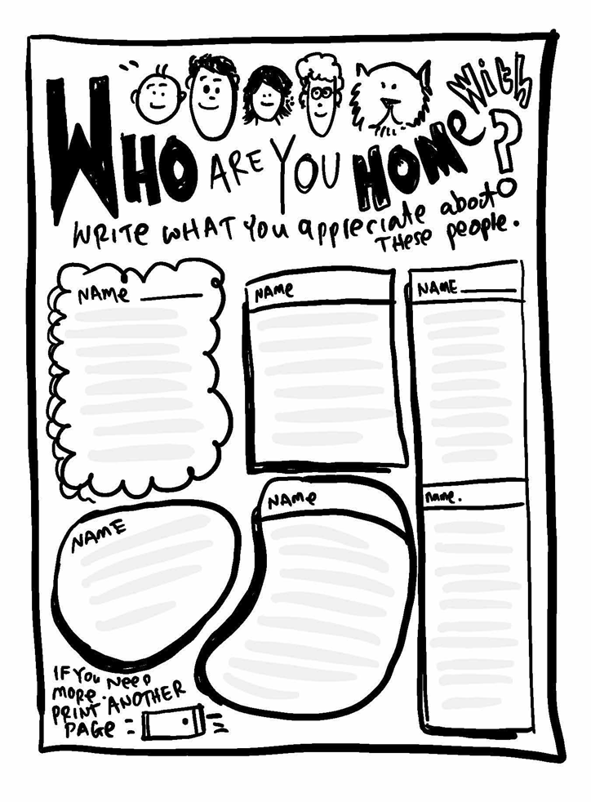

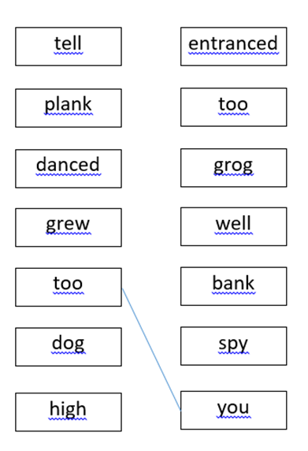

**Maths**

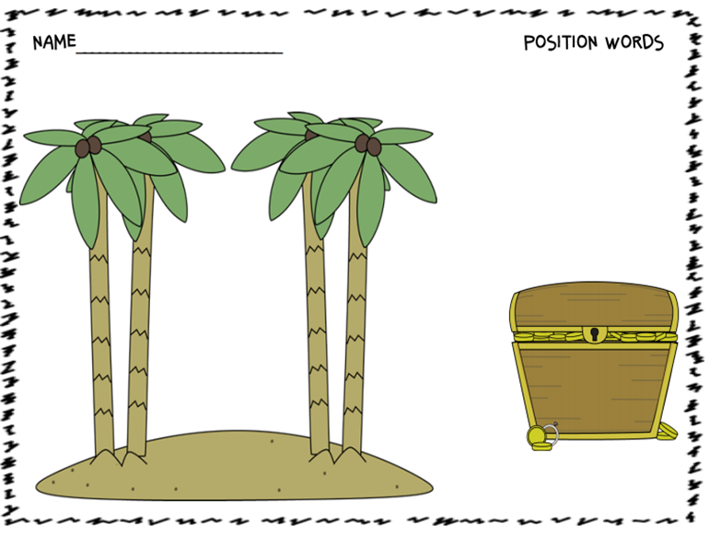

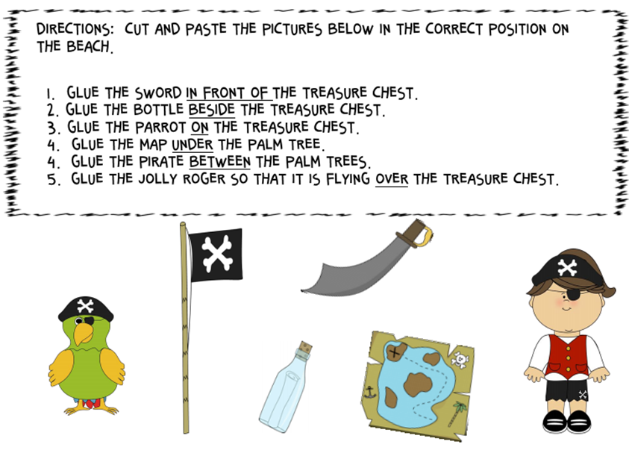

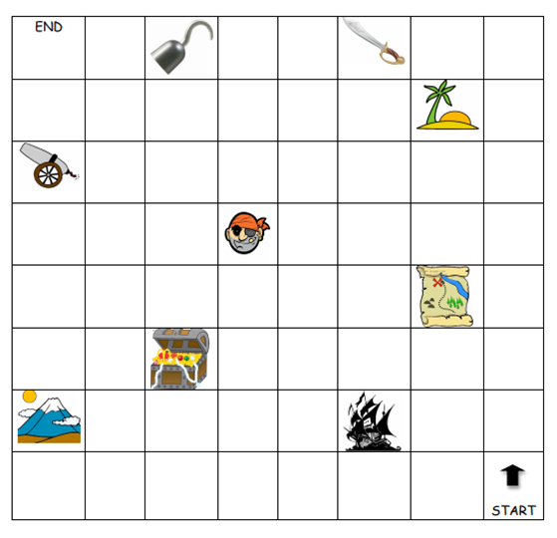

Context

