27.04.20 Our new context is Water/Dwr for this term. Each week the children will learn about different aspects of water. Complete as much as you can and tweet me pictures of all the lovely work you are doing. I really do like to see what you’re all doing at home. More google classroom activities have been added. Miss Chichester 😊

|  |  |  |  |  |
| --- | --- | --- | --- | --- |
| Monday | Tuesday | Wednesday | Thursday | Friday |
| English  Practise your handwriting.  Read the water poem and then copy the poem.  Remember to form all letters in the correct place.  Practise your phonics  Year 1 children – 2 letters that make a sound ‘ai as in mail’  Year 2 children – split digraph a-e The e at the end of the word make the vowel change from it’s sound to it’s name as in m**a**k**e.** | English  The Rainbow Fish (you may have a copy at home)  <https://www.youtube.com/watch?v=QFORvXhub28>  Listen to the story of the rainbow using link above.  Draw a picture of the rainbow fish and retell the story writing sentences.  Remember to use your own words  Capital letters and full stops  Finger spaces between words.  Write about the most important parts of the story. | English  Find the nouns in the story and make a list.  A noun is a naming word. (fish)  How many can you find?  Find the verbs in the story and make a list.  A verb is a doing word. (shimmering)  How many can you find?  Stretch  Find the adjectives in the story and make a list.  An adjective is a describing word. (shiny)  How many can you find? | English   |  |  |  | | --- | --- | --- | | beginning | middle | end | |  |  |  |   I would like the children to plan a story about a ‘rainbow animal’ it could be a ‘rainbow butterfly’ or ‘rainbow snake’ etc They could retell using a story or create their own ideas.  Using a storyboard above, can the children draw and talk about their ideas to you.  Beginning – introduce characters and setting  Middle – what exciting things happen?  End – what happens to the characters? How do they feel? | Creative writing  Write a story about their ‘rainbow animal’  Spidey WAGOLL (what a good one looks like)  Capital letters and full stops  Spaces between words  Letters formed correctly  A beginning, middle and end  Pluto and Super WAGOLL (what a good one looks like)  Use different ways to start a sentence – suddenly, in a flash, in the end etc  Use ordering words - next, then, after that etc  Use adjectives to add description  Use connectives – and, because, so, but  Children can include whatever they want in their story, this is just a guide. |

|  |  |  |  |  |  |  |  |  |  |  |  |  |  |  |  |  |  |  |  |  |  |  |
| --- | --- | --- | --- | --- | --- | --- | --- | --- | --- | --- | --- | --- | --- | --- | --- | --- | --- | --- | --- | --- | --- | --- |
| Maths  Place value is knowing the value of the digits     |  |  | | --- | --- | | Spidey group | Pluto and Supers | | 15 | 165 | | 21 | 154 | | 34 | 278 | | 47 | 345 | | 25 | 639 | | 13 | 267 | | 29 | 503 | | 38 | 409 |   Remember to…  Write the number  Draw the sticks  Partition into tens and units  OR  Partition into hundreds, tens and units  Stretch  Can you partition 4 digit numbers?  2,386 3,897 9,045 5,703 | Maths  Ordering numbers    Choose from | Maths  Comparing numbers  Remember the crocodile always eats the biggest numbers    Choose from | Maths  Rounding numbers  Using a 100 square to help you, round these numbers.  Remember…   * 73 rounded to the nearest 10 is 70 as it is closer to 70 * If a number has a 5 unit then it rounds up * 78 rounded to the nearest 10 is 80 as it is closer to 80     Stretch | Big Maths  CLIC test, Learn its and Safe tests are in the resources section of my class page. |

|  |  |  |  |  |
| --- | --- | --- | --- | --- |
| Knowledge and Understanding  Make a list, make a collage or draw pictures of sources of water. You could find and collect online pictures and put them on JIT.  How many different sources of water can you find? eg the sea, a pond etc  Answer these questions  Why is water so important?  Where do we get water from?  What would happen if we didn’t have water?  Can you think of any questions about water? | Knowledge and Understanding  The rainbow fish had lots of shiny scales which he gave away.  Can you find any shiny materials in your house?  You could draw and label them.  Shiny is the opposite of dull. Dull means it is not shiny.  Can you find any dull material in your house?  Draw a table with a ruler like this  _shiny_________dull___ | Personal and Social  Development  Today is guide dog day.  Can you watch the clip about Alma the guide dog?  <https://www.youtube.com/watch?v=vst_RKnaHVo>    What does a guide dog do?  Make a list of all the ways a guide dog helps people who are blind? | Personal and Social Development  This month our new right of the month is Article 24 ‘Everybody has the right to clean water’  Using this link, play these fun games about find germs, zap germs and washing hands.  <http://www.wateraidgames.org/playgermzapperonline>  Can you design a poster using your hwb account or on paper on why we should wash our hands and use clean water. | Creative development  Use an empty shoebox or cereal box to create your own underwater ocean. Can you add all the creatures that were in the story ‘The Rainbow Fish’?  Add sea plants and coral, you could make sea creatures using recycled materials.  Use your imagination. I look forward to see what you create.  Tweet me a picture if you do! |
| Wellbeing  Try a Joe Wicks daily workout | Wellbeing  Try some cosmic yoga  <https://www.youtube.com/user/CosmicKidsYoga> | Wellbeing  Why not try a dance lesson with Oti Mabuse on youtube or facebook. | Wellbeing  Try out a dough disco with Shonette Bason Wood on twitter or youtube. | Wellbeing  Start the day with some exercises on cbeebies  <https://www.bbc.co.uk/cbeebies/grownups/fun-exercises-to-do-at-home-with-kids> |

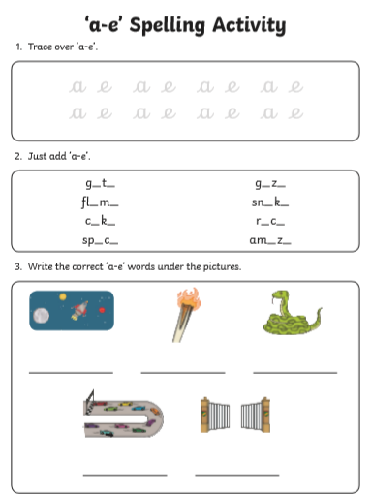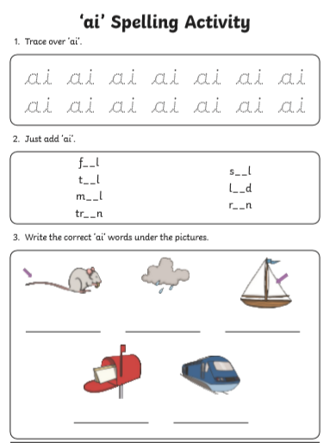

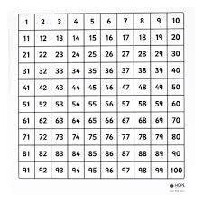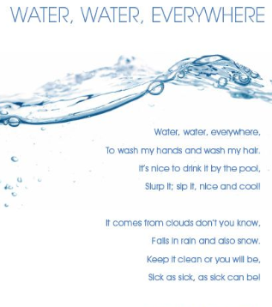Water poem for handwriting for Monday To support rounding numbers on Thursday