 | Monday | Tuesday | Wednesday | Thursday | Friday
English | Read a book – I am reading ‘How do you know its Spring?’ Listen here https://www.youtube.com/watch?v=s_fIEWViJyE | Can you write / draw a list of signs of spring that you might see on your daily walk or out of your window? | Can you play some of the phonics games on the school website? | Can you write your curly caterpillar letters?  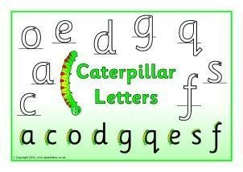 | Can you write about what you like to do in spring?  In Spring I like to ....
Maths | Can you count in 1s, 2s and 10s? | Can you count the spring things? | Can you write number sentences for these adding sums? | Can you write number sentences for these take away sums? | Big Maths – Can you try your Learn it’s in a minute?  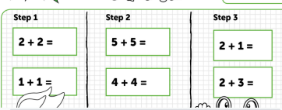  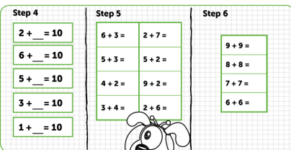
Context/ Wellbeing | Can you paint / draw a spring picture?    You could use a fork to make flowers. | Can you try some spring Cosmic Yoga?  https://www.youtube.com/watch?v=uyj5LooYWyg | Can you write / draw about something that makes you happy?   | Can you order the life cycle of a seed? | Can you paint by numbers with Cyw?  https://cyw.cymru/en/games/create-with-cyw/
20.04.20 – Spring Week, Complete as much as you can, even if it’s just one activity per day, Don’t forget to tweet me @Miss_E_A_Knight so I can see how you are getting on. Miss Knight

