 | Monday | Tuesday | Wednesday | Thursday | Friday
English | This week’s story is ‘Dear Greenpeace’ You can watch it here:  https://www.youtube.com/watch?v=Qz6zULKr6kE | Think about the animals in the story – Can you mind map ideas about how to look after them and the ocean?   | Do you know where you live?    Can you write your address? | Can you write your curly caterpillar letters?  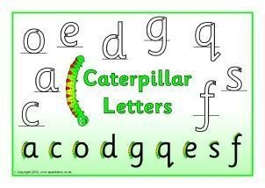 | Can you write your own letter to Greenpeace or you could write to Mrs Thomas with ideas to help look after our school?  
Maths | Can you make a tally chart for each animal? https://www.bbc.co.uk/bitesize/clips/z7r9jxs | How many colours are in a tube of Smarties or your Lego box? Can you make a block graph to count? | Can you make your own underwater themed pictogram on Hwb using j2e? | Can you make a block graph on j2e using this information?  Colour Fish No.  Red 5  Yellow 3  Blue 7  Green 6  Pink 4 | Big Maths – Can you try your Learn it’s in a minute?  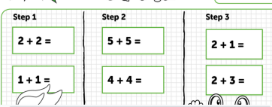  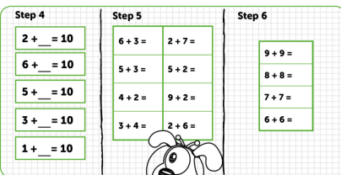
Context/ Wellbeing | Can you test objects in your house and find out if the float or sink in water?  float Sink  Watch this video for some ideas. https://www.youtube.com/watch?v=eQuW8G2QV_Q | Watch this Octonauts episode and think about all the problems plastic can cause in the ocean. Can you make a poster to tell people how to help.  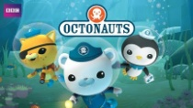  https://www.youtube.com/watch?v=MK1urY639XQ | Can you find your home on a map? What about a family members or friends house? How would you get there? | Can you listen to the whale music - How does it make you feel? Can you create some movements to it?  https://www.youtube.com/watch?time_continue=5229&v=nDqP7kcr-sc&feature=emb_title | Can you try some Dolphin Cosmic Yoga?  https://www.youtube.com/watch?v=YR1OxBk8BF4
18.05.20 – Eco Week, Complete as much as you can, even if it’s just one activity per day, Don’t forget to tweet me @Miss_E_A_Knight so I can see how you are getting on. Miss Knight

