 | Monday | Tuesday | Wednesday | Thursday | Friday
English | Enjoy a new story this week ‘Polly Parrot Picks a Pirate’  https://www.youtube.com/watch?v=ZwEHeNyfEsQ | What do Pirates do? Can you act like a pirate?  - Sail the Ship  - Climb the Rigging  - Walk the plant  - Load the cannons  - Feed the parrots   | Can you make a list of all the different job pirates have to do?  https://www.youtube.com/watch?v=jx79dLuqPwQ | Can you practice your tricky words? | We need some new Pirates; can you write an advert to encourage people to join the crew?
Maths | Can you remember your counting in 2s?  https://www.topmarks.co.uk/times-tables/coconut-multiples | Can you count in 2s? | Can you count in 5s?  https://www.youtube.com/watch?v=EemjeA2Djjw | Can you try some repeated addition? | Big Maths – Can you try your Learn it’s in a minute?  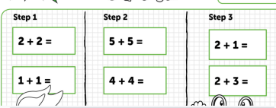  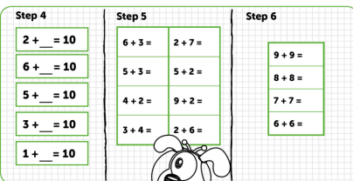
Context/ Wellbeing | Can you compare the seaside of the past to today?  http://www.crickweb.co.uk/ks1history.html#seaside | Can you complete the active Pirate workout?  https://www.youtube.com/watch?v=oe_HDfdmnaM | Refugee Week Activity | Can you design your own Polly the Parrot?  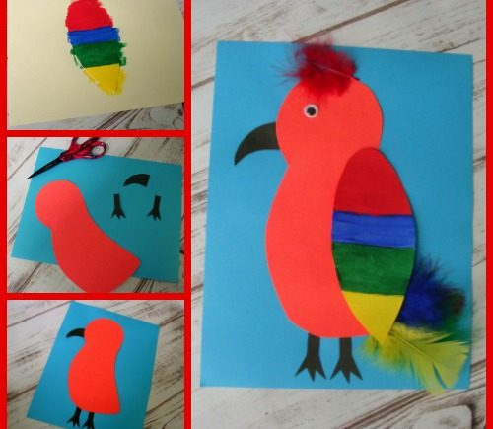 | Enjoy another Pirate episode of Ahoi! on Cyw Tiwb.  https://www.s4c.cymru/clic/programme/803348769
18.05.20 – Pirate Job Week, Complete as much as you can, even if it’s just one activity per day, Don’t forget to tweet me @Miss_E_A_Knight so I can see how you are getting on. Miss Knight

