|  |  |  |  |  |  |
| --- | --- | --- | --- | --- | --- |
|  | Monday | Tuesday | Wednesday | Thursday | Friday |
| English | Read the story ‘When I grow up I want to be..’  What do you want to be when you grow up?    <https://www.youtube.com/watch?v=hp0h_1ZI_UM> | Draw and label a picture of what you want to be when you grow up! | Write some fun facts about you, that you would like your teacher next year to know! | How many phase 2 sounds do you know? How many phase 3 sounds do you know? | How many of the first 100 high frequency words can you read and write? |
| Maths | How many number patterns can you create using the numbers 1, 2, 3? I’ll start you off!  111222333111222333  123123123123123123  312312312312312312 | Can you complete the number sequencing game?    <https://www.topmarks.co.uk/ordering-and-sequencing/caterpillar-ordering> | Can you fill in the missing numbers on the 100 square? | Can you watch the odds and even video…    <https://www.youtube.com/watch?v=L6Sz5matzYI>  ...then complete the odds and evens game?    <https://www.topmarks.co.uk/learning-to-count/coconut-odd-or-even> | Can you complete the number sequence maze to help the police officer get to his car? |
| Context/ Wellbeing | Can you decorate a hope jar and fill it with hopes and dreams for your future? You could draw pictures or write your hopes. | Can you plant a seed and watch it grow? How long does it take? How does it change? | Can you read through the Welsh weather words and then complete a weather diary for the week? | Create a bird feeder kebab using scrap food from your house and some string! You could go for a walk and hang your bird feeder on a tree! | It’s Friday so get your body moving with a PE session by Joe Wicks!    <https://www.youtube.com/watch?v=d3LPrhI0v-w> |

13.07.20 – HAPPY LAST WEEK DOSBARTH COMET! This week we will be thinking about our hopes and dreams. We’ll be completing English activities based on what we want to be when we grow up and what we would like our teachers to know about us.

In maths we’ll be looking at patterns, number sequencing and odd and even numbers.

In context we’ll be creating hope jars for the future, planting a seed and completing a Welsh weather activity.

I can’t wait to see all of the amazing work that you do! Don’t forget to tweet me photos of what you have done @bowen_miss.

Miss Bowen 

**Resources**

**English**

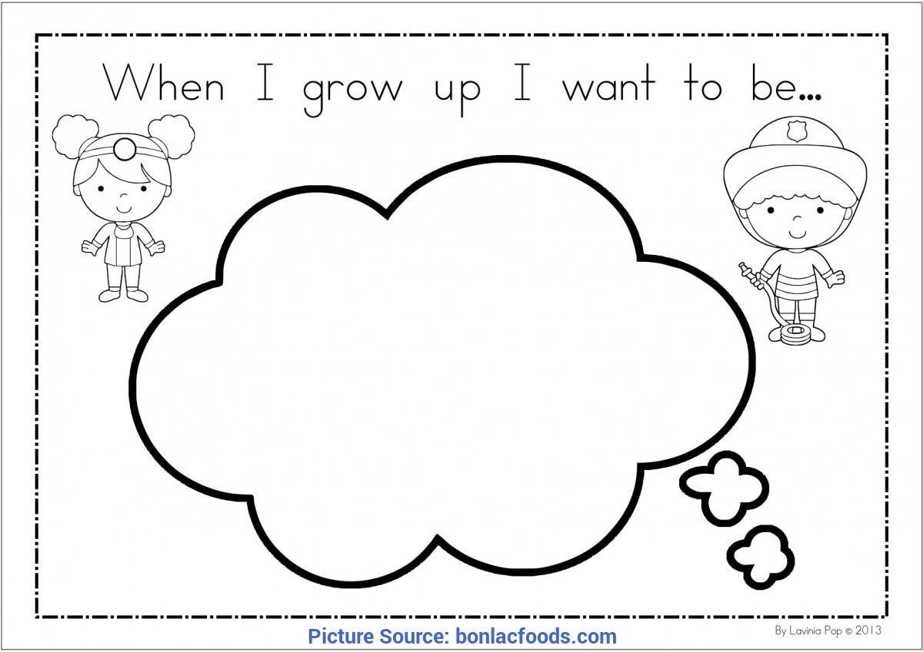

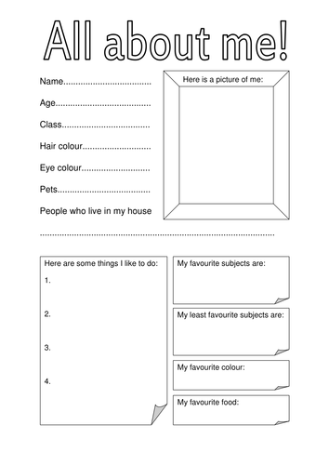

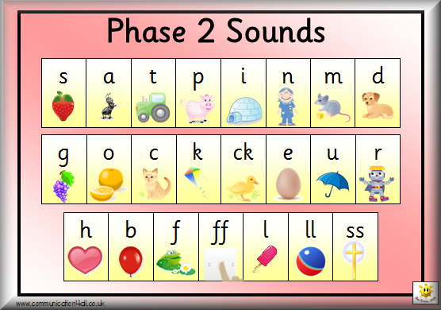

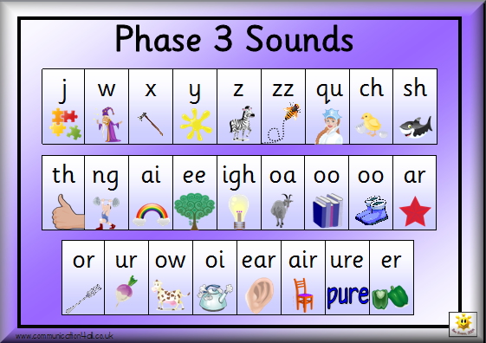

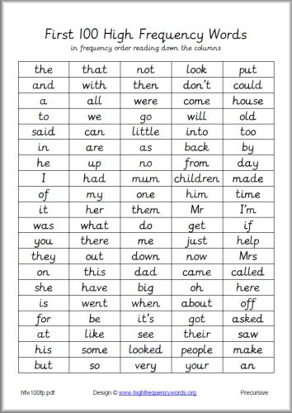

**Maths**

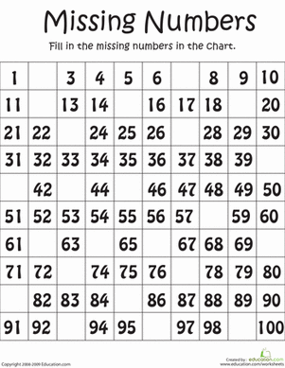

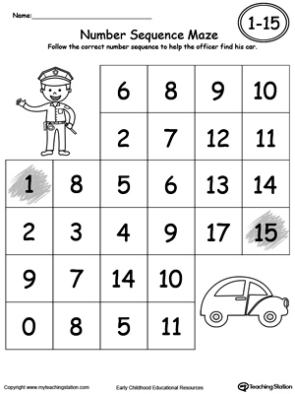

**Context**

