 | Monday | Tuesday | Wednesday | Thursday | Friday
English | This week we are reading – The Lighthouse Keeper’s Lunch.  https://www.youtube.com/watch?v=46wCRq50Wwg | Can you taste some different foods at home and sort them into your own groups.    You could use like / dislike or sweet / sour / salty. | Can you make a list of ingredients you used in your own sandwich design?  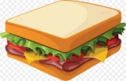 | Can you write your Zig Zag Monster letters?  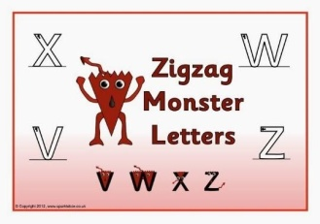 | Can you write a recipe for your own sandwiches?  Can you use your ordering words, First, Then, Next & Last?
Maths |  |  |  |  | Big Maths – Can you try your Learn it’s in a minute?  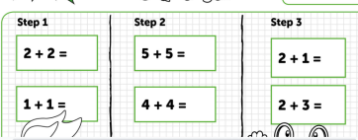  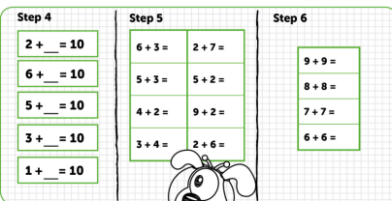
Context/ Wellbeing | Can you create a 3D lighthouse picture?  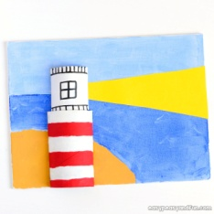  You could recycle a toilet roll to make the lighthouse. | Can you design your own sandwich and make it for someone at home?  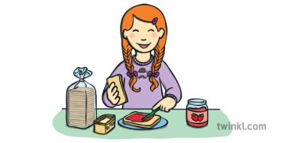  Will you use mustard too? | Can you play a game with your family? Remember to take turns and follow the rules. | Barnaby Bear goes to the Seaside – Can you watch the video and then make a list of things you see at the beach?  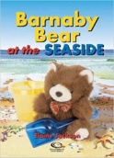  https://www.youtube.com/watch?v=6qO0mu6YJW8 | Can you play the shape game in welsh on Cyw?  https://cyw.cymru/en/games/toot-game-wayne-the-crane/
11.05.20 – On the Beach Week, Complete as much as you can, even if it’s just one activity per day, Don’t forget to tweet me @Miss_E_A_Knight so I can see how you are getting on. Miss Knight

