 | Monday | Tuesday | Wednesday | Thursday | Friday
English | Enjoy this week’s story ‘Pirates Love Underpants!’  https://www.youtube.com/watch?v=Vd8_Y1bEzA8 | Can you design your own Pirate pants and write as many ‘p’ words as you can think of in them?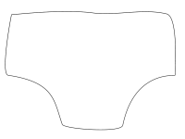 | Can you use the game board to create your own story? Can you tell it in a pirate voice? | Can you practice your tricky words? | Can you write your own Pirate story and send it in a bottle to the Pirates?
Maths | Can you remember the names of the 2D shapes?  What shapes can you find around the house?  https://www.bbc.co.uk/bitesize/clips/zhnvcdm | Can you recognise the shapes by their properties?  https://www.education.com/game/identifying-shapes-attributes/ | Can you recap what you know about 3D shapes?  https://www.bbc.co.uk/bitesize/topics/zjv39j6/articles/zgqpk2p | Can you go on a 3D shape hunt? | Big Maths – Can you try your Learn it’s in a minute?  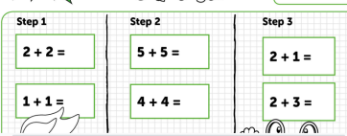  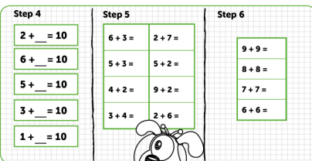
Context/ Wellbeing | Its World Ocean Day, can you watch the videos and make your own save the ocean poster?  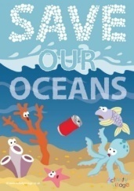  https://worldoceanday.school/ | Can you label the parts of a Pirate Ship? | Can you make pirate ship that will float and carry your treasure? | Can you make some music using water?  Watch how here:  https://www.youtube.com/watch?v=sIO-JhMvu6M | Enjoy another Pirate episode of Ahoi! on Cyw Tiwb.  https://www.s4c.cymru/clic/programme/803348753
08.06.20 –Pirate Ship Week, Complete as much as you can, even if it’s just one activity per day, Don’t forget to tweet me @Miss_E_A_Knight so I can see how you are getting on. Miss Knight

