|  |  |  |  |  |  |
| --- | --- | --- | --- | --- | --- |
|  | Monday | Tuesday | Wednesday | Thursday | Friday |
| English | You lucky things get to read the book ‘Molly Rogers Pirate Girl’ today!’    <https://www.youtube.com/watch?v=3Parjk2LY10> | Can you create your own pirate name using alliteration? Think of an adjective that starts with the same letter as your first name.  E.g. Naughty Nelly Angry Anton  **Mine is Mischievous Miss Bowen!** | It’s your turn to write a letter in a bottle! Imagine you are trapped on a pirate ship, who would you send a letter to? What would you write? | Watch the phonics pirates!  Can you spot any digraphs?    <https://www.youtube.com/watch?v=qXSUVoByRw0> | Can you complete the pirate wordsearch? |
| Maths | Division - Can you share out the gold coins between the pirates? How many does each pirate get? | Can you help curious George share out the dog treats so that each dog has the same amount?    <https://pbskids.org/curiousgeorge/busyday/dogs/> | Can you complete the division questions?  Imagine you are sharing out pirate sweets!  6 sweets shared between 3 pirates?  4 sweets shared between 1 pirate?  12 sweets shared between 4 pirates?  10 sweets shared between 5 pirates?  8 sweets shared between 8 pirates? | Can you complete the quick fire maths questions?    <https://www.topmarks.co.uk/maths-games/hit-the-button> | Listen to the ‘Doubles’ rap, then see if it can help you to answer some of your Big Maths Learn Its!    <https://www.youtube.com/watch?v=8jOzhiACB68> |
| Context/ Wellbeing | Listen to the story ‘Silly Billy’ by Anthony Brown. Can you make your own worry doll? You could use a wooden peg or a lollipop stick.    <https://www.youtube.com/watch?v=CDvh8fWhbPE> | Read the story ‘Beautiful oops by Barney Saltzberg!’  Can you make a mark/stain/paint splat on a piece of paper and turn it into a picture?    <https://www.youtube.com/watch?v=cUUSxgVGQxk> | Mindfulness - Here and Now  Read the story below, think about what colours the little boy might have seen, what shapes were the blocks? What sound do you think they made?  Close your eyes and breathe. What parts of your body move when you are breathing? Can you feel a part of your body that stays still? Hold a feather or tissue in front of your nose and mouth. What happens to it when you breathe in? What happens when you breathe out? | Watch the Welsh song all about feelings!  Can you draw a matching face for each feeling?  How are you feeling today?    <https://www.youtube.com/watch?v=-aw59C-89P8> | Complete the rainbow breathing activity. This activity can help you to feel calm and relaxed if you feel sad, worried or angry!    <https://www.youtube.com/watch?v=O29e4rRMrV4> |

06.07.20 – Hello there me hearties, this week we will be reading the amazing story ‘Molly Rogers Pirate Girl’. We will be using alliteration to create pirate names and writing our own letter in a bottle.

In maths we will be completing division activities and thinking about how dividing is the same as sharing things out equally.

In context we will be thinking about our thoughts and worries. We’ll read Silly Billy and make our own worry dolls and we will also complete mindfulness activities that will help us to deal with any worries we might have in the future.

Don't forget to complete as many activities as possible and ask a grown up to send me photos/videos of your work on Twitter. You may even receive some special post next week!

I can't wait to see your work!

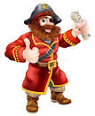Miss Bowen 

**Resources**

**English**

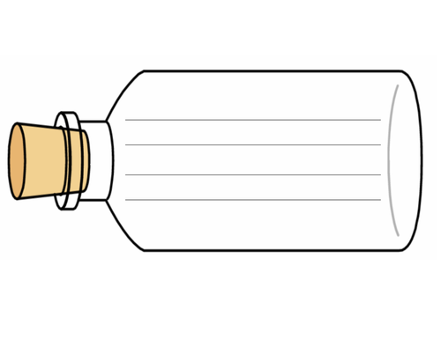

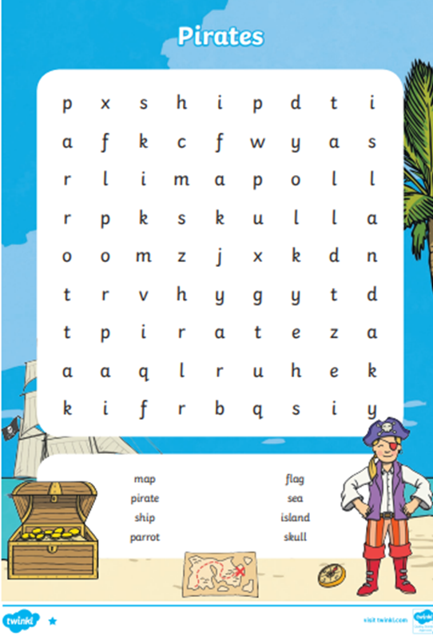

**Maths**

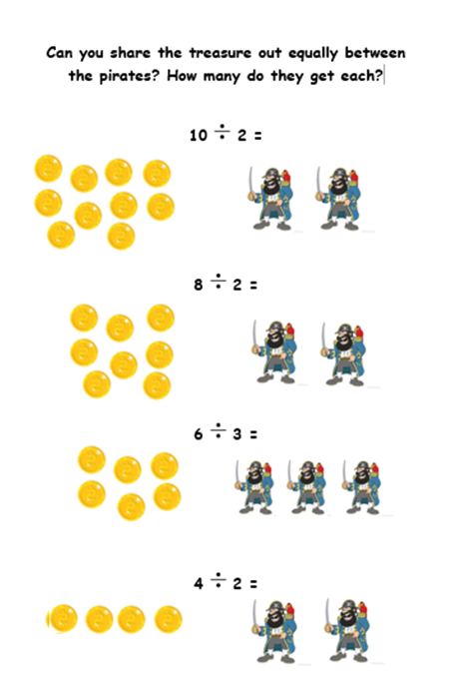

**Context**

**Mindfulness story**

This is a short story about 2 children who are your age.

The children, Lucy and Jack are with their Mum, waiting to go swimming. Jack is playing with some blocks on wires in the reception area of the pool. He is watching, feeling and hearing the coloured blocks move along the wires. He notices their bright colours and different shapes and the way they make a ‘clunk’ sound when they touch each other.