 | Monday | Tuesday | Wednesday | Thursday | Friday
English | Enjoy the story of the Snail and the Whale https://www.bbc.co.uk/iplayer/episode/m000cslw/the-snail-and-the-whale | Can you say a sentence about each of these pictures?  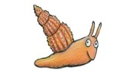  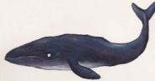   | Can you make a story map of ‘The snail and the whale’ ? | Can you write your one armed robot letters? 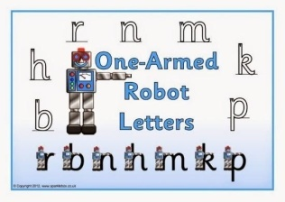 | Can you write a story about a big and small animal of your choice?  ie: The shark and the starfish
Maths | Can you play the length game? https://www.topmarks.co.uk/early-years/lets-compare | Can you measure 10 things around your house? Remember to use something the same size to measure with (cubes/lego bricks/pasta shapes)  Object Length  book  fork  bottle | Can you measure in cm?  https://www.topmarks.co.uk/maths-games/measuring-in-cm  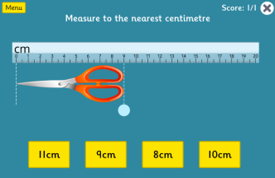 | Can you make a list of things longer & shorter than 10cm?  Longer Shorter  Pencil Coins | Big Maths – Can you try your Learn it’s in a minute?  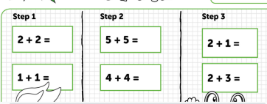  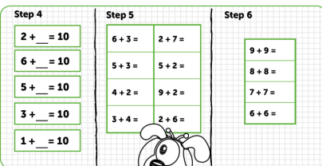
Context/ Wellbeing/ Welsh | Can you cut out shapes to make your own snail picture?  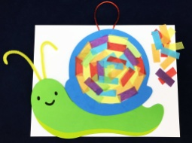 | Can you try some Octopus Cosmic Yoga?  https://www.youtube.com/watch?v=hUBRoLRioiY | Can you research some Sea creatures – Name them and describe them? Use this clip tp help https://www.bbc.co.uk/bitesize/clips/zmxqxnb  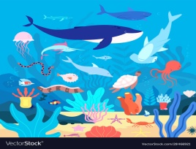 | Can you order these sea creatures from shortest to longest?  shark 4m  whale 29m  jellyfish 2m  Sea turtle 3m  dolphin 5m  octopus 1m | Can you watch Octonots in Welsh?  https://www.s4c.cymru/clic/programme/500613257
04.05.20 – Sea Creature Week, Complete as much as you can, even if it’s just one activity per day, Don’t forget to tweet me @Miss_E_A_Knight so I can see how you are getting on. Miss Knight

