 | Monday | Tuesday | Wednesday | Thursday | Friday
English | This week’s story is ‘How I became a Pirate’  https://www.youtube.com/watch?v=5-0VHrSwg2k | Can you draw and label a pirate?  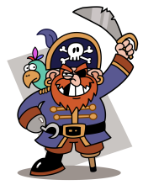 | Can you read the pirate words?    https://www.ictgames.com/mobilePage/poopDeck/index.html | Can you practice your tricky words? | Can you write a pirate fact file?
Maths |  |  | Can you complete the subtractions? | Can you complete the subtractions? | Big Maths – Can you try your Learn it’s in a minute?  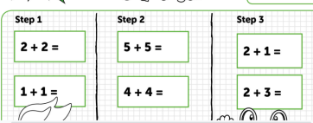  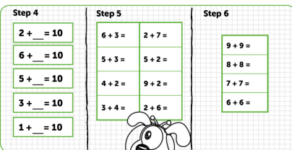
Context/ Wellbeing | Did you celebrate Eid? What did you do? Can you draw a picture and write a sentence about it?    Or something else you did over half term? | Can you experiment with growing some Salt Crystals?  https://www.youtube.com/watch?v=Vl2iY-rcLcM | Can you make healthy Pirate Smoothie? | Can you try some Pirate Cosmic yoga?  https://www.youtube.com/watch?v=T_0P5grVoyg | Why not watch Ahoi! on Cyw Tiwb https://www.s4c.cymru/clic/programme/803348737
01.06.20 – Introduction to Pirates, Complete as much as you can, even if it’s just one activity per day, Don’t forget to tweet me @Miss_E_A_Knight so I can see how you are getting on. Miss Knight

