|  |  |
| --- | --- |
| **covid – 19 symptoms**  **what you need to know and do** | Adamsdown Primary (@AdamsdownPrm) | Twitter |
| **Doctors of the World are really pleased to be able to share with you Coronavirus (COVID-19) advice in 49 languages, which were produced in partnership with the British Red Cross.**  **Below you can find information in ALL LANGUAGES to view or download for FREE.**  English, Albanian, Amharic, Arabic, Armenian, Bengali, Bulgarian, Burmese, Czech, Dari, Estonian, Farsi, Filipino, French, German. Greek, Gujarati, Hausa, Hindi, Hungarian, Indonesian, Italian, Kiswahili, Krio, Kurdish Sorani, Latvian, Lithuanian, Oromo, Malayalam, Nepali, Pashto, Polish, Portuguese, Punjabi, Romanian, Russian, Simplified Chinese, Traditional Chinese, Sindhi, Slovak, Spanish, Somali, Tamil, Tigrinya, Turkish, Urdu, Vietnamese, Wolof, Yiddish.  Please **click** onto the link below to access your preferred language:  <https://www.doctorsoftheworld.org.uk/coronavirus-information/> | |

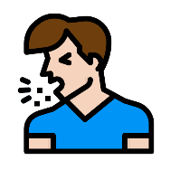 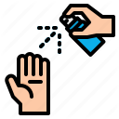 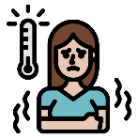

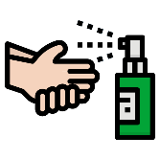 

**NHS App:**

**Get advice about Covid-19, check your symptoms and various other services that are available via the NHS App.**

**Please click onto the link to access the information:**[**covid19.nhs.uk**](https://www.covid19.nhs.uk/)